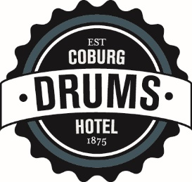

DRUMS 2022 AFL FOOTY TIPPING COMPETITION TERMS AND CONDITIONS

Entry into “Drums Footy Tipping Competition” Is $25

FOOTY TIPPING COMP PRIZEMONEY:
All entry monies will be paid out as prizes, and in the following manner:

- 1st Place: 50% of Footy Tipping Comp Pool
- 2nd Place: 30% of Footy Tipping Comp Pool
- 3rd Place: 20% of Footy Tipping Comp Pool
- Starting Pool of $300.00

Example:
50 Patrons Join The Footy Tipping Competition. (Total Pool = $1,550 ie, 50x$25 + $300 starting pool)
Total Footy Tipping Comp Prize money would be shared as follows: ($1,550):

- 1st Place $775 (50% x $1,550)
- 2nd Place $465 (30% x $1,550)
- 3rd Place $310 (20% x $1,550)
- TOTAL $1,550

GENERAL:

- The Entrant with the most points at the end of the season will be declared the winner.
- In the event of a tie, the prizemoney will be proportionally allocated. For example, if there is a tie for first place between 2 entrants, then the prize money for both 1st place and 2nd place would be aggregated and then split equally between the two entrants. (In this example, third prize would remain unchanged.)
- In the event of multiple ties, (eg 5 people tied for first place) then the prizemoney would be aggregated accordingly and then equally split between all of the winners
- $25 Entry Fee must be paid in full prior to first round.
- Football Fixtures will be given out to Each Entrant to record the tips.
- Selections must have been made and handed in at Drums by 6pm on the evening of the First Match of each Round.
- Entrants can put in their selections either in person, by calling up Drums Hotel on (03) 9354 1729, or online at drumshotel.com.au/footy
- If selections are received after this time, or not handed in at all, then the entrant will receive the “Away Teams” as their default selections for that particular round.
- Management of the hotel will be ultimately responsible for administering the competition and for resolving any disputes or issues that may arise. Its decision will be final.
- Each entrant will receive a ‘pot card’ on handing in of tips for each round, where the entrant can purchase a pot of tap beer or soft drink and get 1 pot of tap beer or soft drink free.

Scoring is as follows:
- WIN 1 Point
- DRAW 0 Points
- LOSS 0 Points

